

Approval Management System

(AMS)

**User Manual**

**Objective:**

This manual introduces you to the functionalities involved in tracking and approval

of FAPA/PR through online, Timely closure of requests.

**Definition:**

* AMS- Approval Management System
* FAPA - Capital Purchase Request Form
* PR - Service Request Form & Non Stock Request Form
* Save -This allows you to create the AMS form as draft and return to complete the requests that are pending due to item code creation or vendor code creation.
* Submit - This allows you to route the completed form to the next level.
* Reset - This allows you to reset the form before saving and return to complete the fresh request form.
* Cancel - This allows you to delete the form and return to fill the form again.

Index

|  |  |  |  |
| --- | --- | --- | --- |
| **Sr. No.** | **Section** | **Sub - Section** |  |
| 1 | Log In LFG Portal | Log In Credentials |  |
|  |  | Forgot Password |  |
|  |  | Change Password |  |
| 2 | AMS Module | Capital Purchase Request Form - FAPA | Save  Submit  Reset  Delete |
|  |  | Service Request Form (PR) | Save  Submit  Reset  Delete |
|  |  | Non Stock Request Form (PR) | Save  Submit  Reset  Delete |

**1. Getting Started:**

To access the AMS Module the employee is required to use the below URL

<http://lfg.nipponpaint-groupar.com/>

**1.1 Login Credentials:**

* User ID :
* Password :

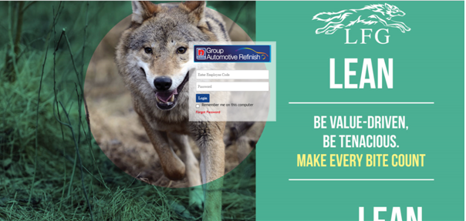

**1.2 Forgot Password:**

In case forgetting the password, Click forgot password after putting the employee code then you have received the password on mail.

**1.3 Change Password:**

Employee can change the password from the TAB “CHANGE PASSWORD” on TOP RIGHT HAND SIDE.

**1.4 HOME PAGE**

After login, the employee will be directed to the Home page of LFG Portal with AMS Module:

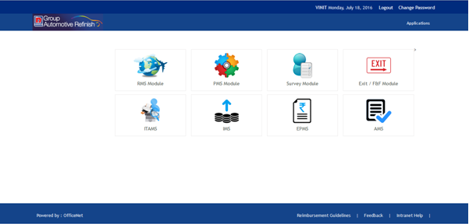

2. Once the use will click AMS, a Dashboard will open and show the summary of the following:

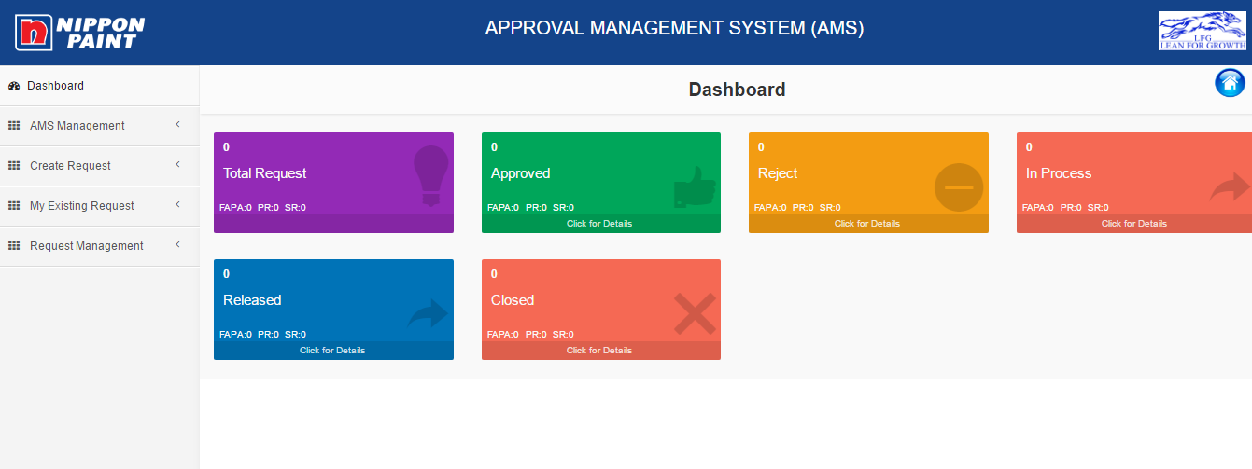

2.1 Total Request

2.2 Approved - Clickable for details

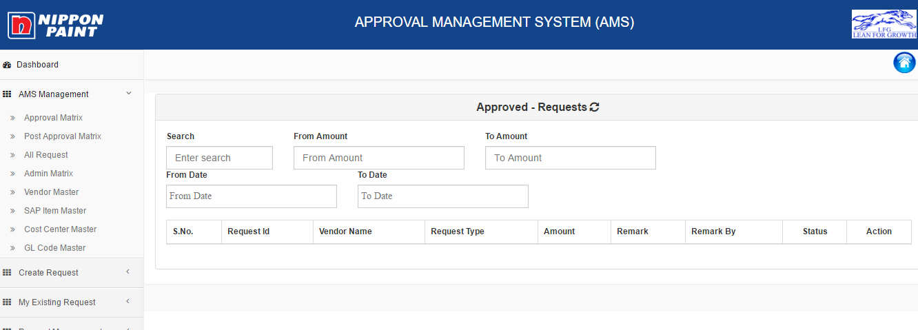

2.3 Rejected Requests - Clickable for details

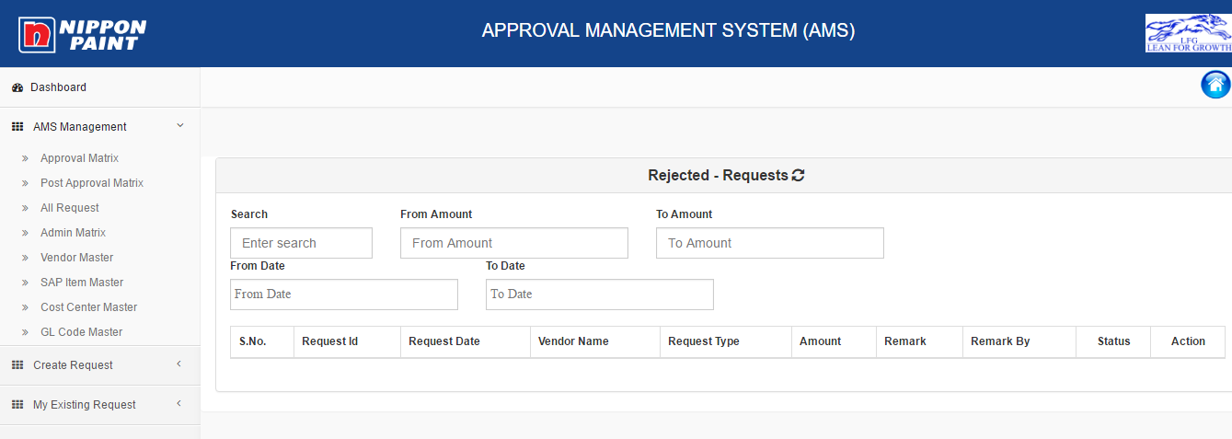

2.4 In Process - Clickable for details

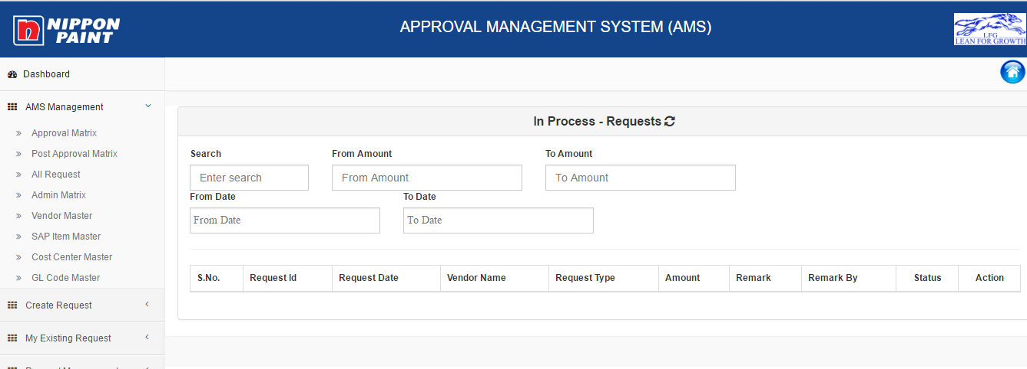

2.5 Released - Clickable for details

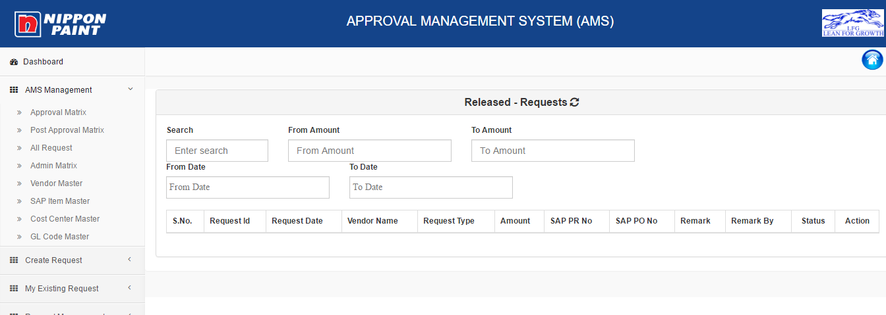

2.6 Closed - Clickable for details

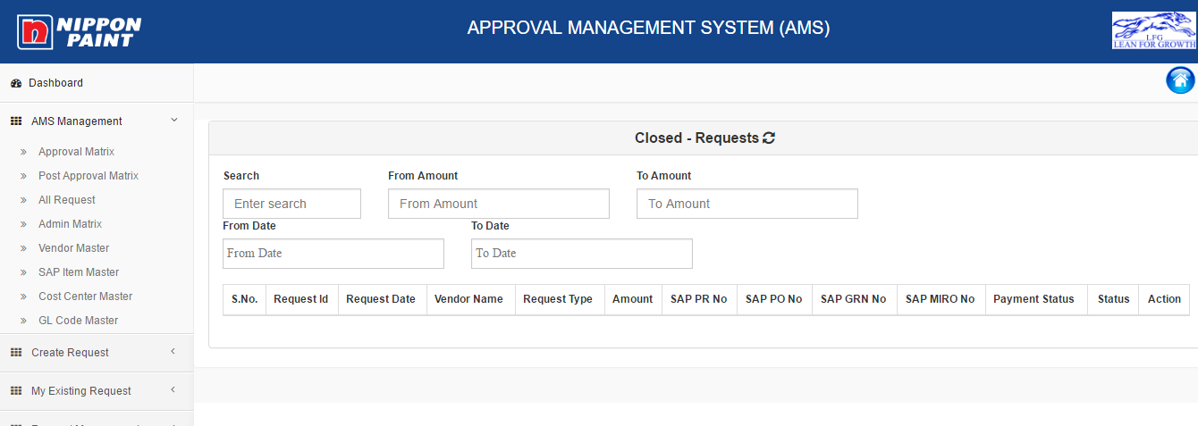

3. When User will click on Create Request:

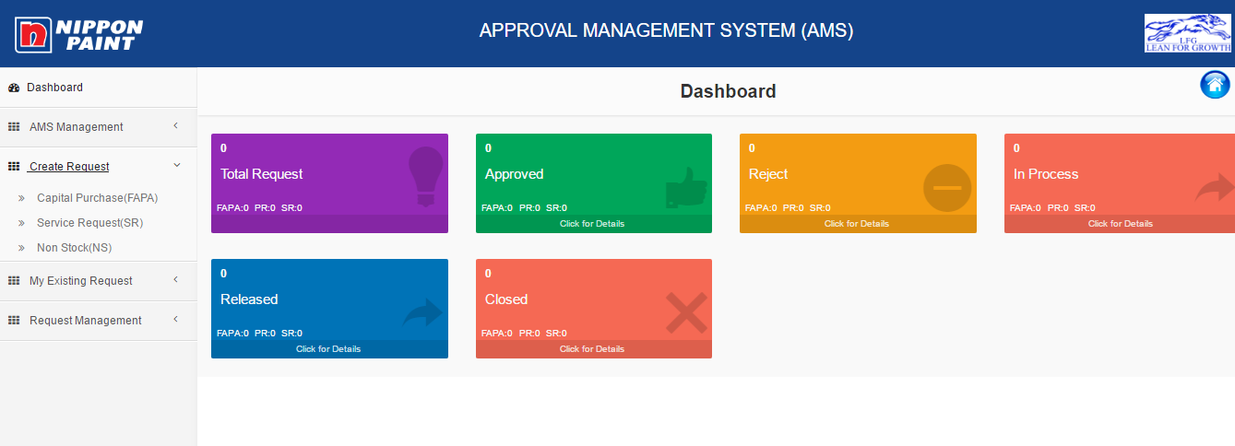

Sub Menu:

* Capital Purchases (FAPA)
* Service Requests (SR)
* Non Stock (NS)

3.1 Once the user will click on **FAPA - Capital Purchase Form Request**, FAPA form will open:

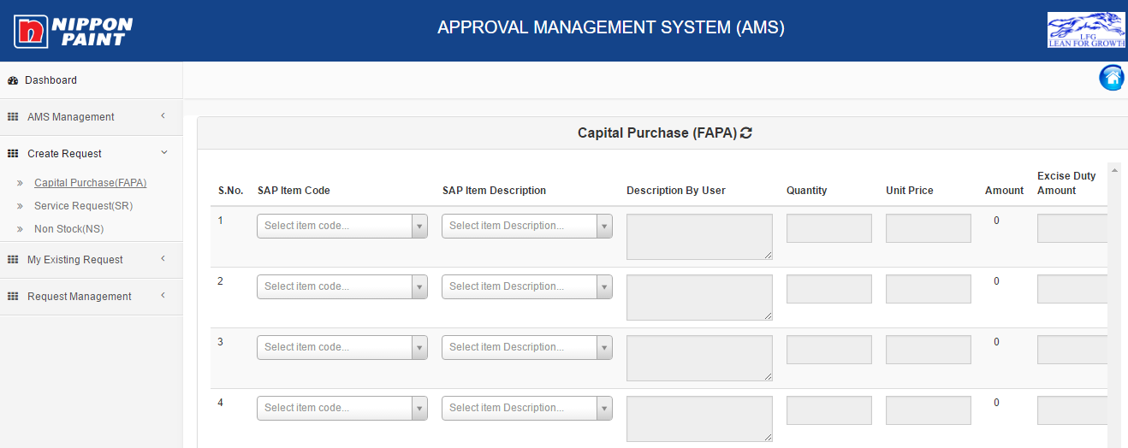

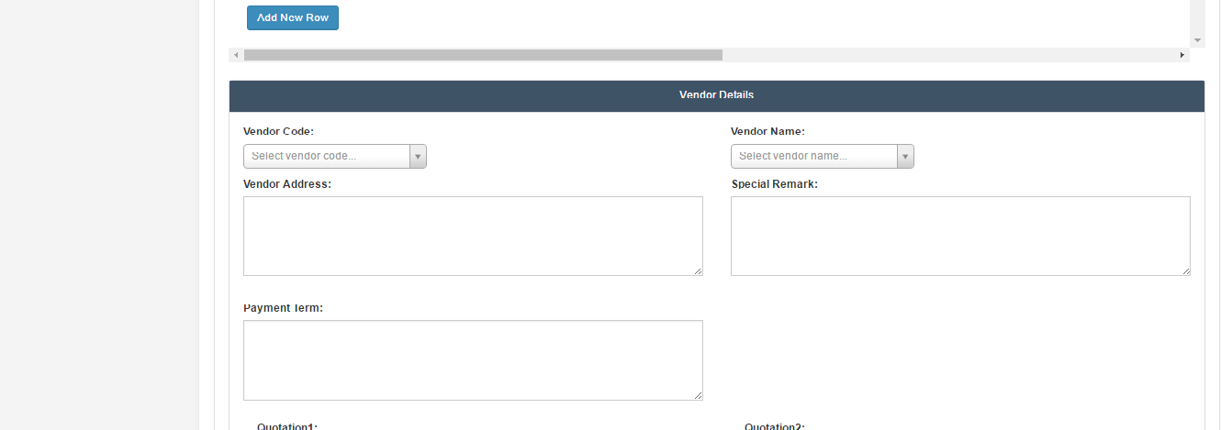

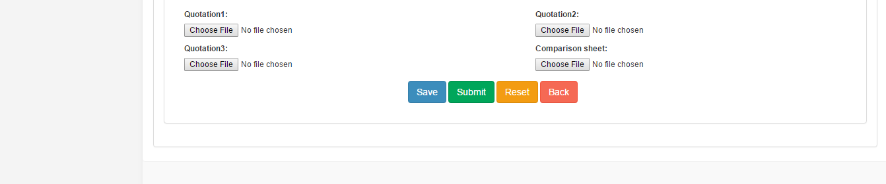

FAPA will have following fields:

**3.1.1. SAP ITEM CODE*-** Mandatory drop down Option. (History Button will appear if item exists or item has history)

**3.1.2. SAP ITEM DESCRIPTION *-** Mandatory drop down searchable option (History Button will appear if item exists or item has history)

In Case user selects item code then the description will come automatically or vice versa.

**3.1.3. Description by user*-** Mandatory Text Box

**3.1.4. Quantity\*** – Mandatory Numeric Text Box (Blank)

**3.1.5. Unit Price**- Optional Numeric Text Box (Blank)

**3.1.6. Amount** - Automatic Calculation ( Qty*Unit price)

**3.1.7. Excise Duty** - Optional Text Box (Blank)

**3.1.8.** Once the user clicks on **Add Tax** **Button** - A pop up window will open

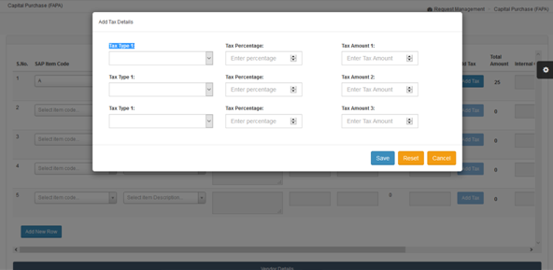

This is an optional field, but becomes mandatory if the user enters the unit price.

Fields like:

* **Tax Type**
* **Tax Percentage**
* **Tax Amount**

**3.1.9. Total Amount** - This will show the total amount (Pre-formulated i.e. Amount + Excise duty + Tax amount)

**3.1.10. Internal Order No.\*** : Blank Text Box. Internal order no will validate from the database and total request amount of FAPA will be equal or less than the internal order amount. If exceeds then message will be shown **“Requested amount is exceeding from the balanced amount of internal order.”**

**3.1.11. GL Code -** General Ledger Code

**3.1.12. Profit Center -** Drop Down Menu

**3.1.13.** Delete Button

**3.1.14. Add New Row** - This will add new rows with the above input fields.

**3.1.15. Vendor Details**

**a. Vendor Code\*** : Drop down Option – Mandatory field in case of amount given

**b. Vendor Name\*** : Drop down option- Mandatory field in case of amount given

If does not comes in searchable option then the user can select creation of vendor code

Note: if user selects Vendor code then name automatically appears and vice versa.

**3.1.16. Quotation:** Quotation with browse options. One browsing attachment is mandatory if vendor details have been filled up by the user otherwise none is compulsory.

After filling all the details, Four option are there:

* **Save** -This allows you to create the AMS form as draft and return to complete the requests that are pending due to item code creation or vendor code creation.
* **Submit** - This allows you to route the completed form to the next level.
* **Reset** - This allows you to reset the form before saving and return to complete the fresh request form.
* **Cancel** - This allows you to delete the form and return to fill the form again.

After **Submission**:

Case 1: Without Amount & Vendor details

* If user submits the form without giving the amount & vendor details then this request will go to Purchase dept.
* After purchase dept. submission, it will go to Divisional Head (D.H.)
* After approval of D.H., it will go Finance dept.
* After checking and approval of Finance dept., It will go to the president/D.H. for approval as per limits.

Process Flow:

User🡪Purchase dept🡪 Divisional Head 🡪 Finance 🡪President/D.H.🡪Purchase dept.

Case 2: With Amount & Vendor details

* If user submits the form with giving the amount & vendor details then this request will go to Divisional Head.
* After approval of D.H., it will go Purchase dept.
* After purchase dept. submission, it will go to Finance dept.
* After checking and approval of Finance dept., it will go to the president/D.H. for approval as per limits.

3.2. When user Clicks on **Service Request (PR)**, the form will open:

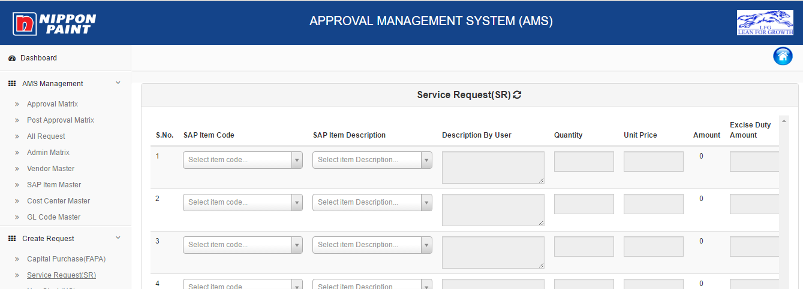





Service Request PR form will have following fields:

**3.2.1. SAP ITEM CODE*-** Mandatory drop down Option. (History Button will appear if the item exists or item has history)

**3.2.2. SAP ITEM DESCRIPTION *-** Mandatory drop down searchable option (History Button will appear if the item exists or item has history)

In Case user selects item code then the description will come automatically or vice versa.

**3.2.3. Description by user*-** Mandatory Text Box

**3.2.4. Quantity\*** – Mandatory Numeric Text Box (Blank)

**3.2.5. Unit Price**- Optional Numeric Text Box (Blank)

**3.2.6. Amount** - Automatic Calculation ( Qty*Unit price)

**3.2.7. Excise Duty** - Optional Text Box (Blank)

**3.2.8.** Once the user clicks on **Add Tax** **Button** - A pop up window will open



This is an optional field, but becomes mandatory if the user enters the unit price.

Fields like:

* **Tax Type**
* **Tax Percentage**
* **Tax Amount**

**3.2.9. Total Amount** - This will show the total amount (Pre-formulated i.e. Amount + Excise duty + Tax amount)

**3.2.10. Internal Order No.\*** : Blank Text Box. Internal order no will validate from the database and total request amount of FAPA will be equal or less than the internal order amount. If exceeds then message will be shown **“Requested amount is exceeding from the balanced amount of internal order.”**

**3.2.11. GL Code -** General Ledger Code

**3.2.12. Profit Center -** Drop Down Menu

**3.2.13.** Delete Button

**3.2.14. Add New Row** - This will add new rows with the above input fields.

**3.2.15. Vendor Details**

**a. Vendor Code\*** : Drop down Option – Mandatory field in case of amount given

**b. Vendor Name\*** : Drop down option- Mandatory field in case of amount given

If does not comes in searchable option then the user can select creation of vendor code

Note: if user selects Vendor code then name automatically appears and vice versa.

**3.16. Quotaion:** Quotation with browse options. One browsing attachment is mandatory if

vendor details have been filled up by the user otherwise none is compulsory.

After filling all the details, Four option are there:

* **Save** -This allows you to create the AMS form as draft and return to complete the requests that are pending due to item code creation or vendor code creation.
* **Submit** - This allows you to route the completed form to the next level.
* **Reset** - This allows you to reset the form before saving and return to complete the fresh request form.
* **Cancel** - This allows you to delete the form and return to fill the form again.

After Submission:

Case 1: without amount & Vendor details

* If user submits the form without giving the amount & vendor details then this request will go to Purchase dept.
* After purchase dept. submission, it will go to Divisional Head (D.H.)
* After approval of D.H., it will go Finance dept.
* After checking and approval of Finance dept., It will go to the president/D.H. for approval as per limits.

Process Flow:

User🡪Purchase dept🡪 Divisional Head 🡪 Finance 🡪President/D.H.🡪Purchase dept.

Case 2: with amount & Vendor details

* If user submits the form with giving the amount & vendor details then this request will go to Divisional Head.
* After approval of D.H., it will go Purchase dept.
* After purchase dept. submission, it will go to Finance dept.
* After checking and approval of Finance dept., it will go to the president/D.H. for approval as per limits.

Process Flow:

1. **In case of no change in request**.

User🡪 Divisional Head 🡪Purchase dept.🡪 Finance 🡪President/D.H.🡪Purchase dept.

1. **In case of any change in request**.

User🡪 Divisional Head 🡪Purchase dept.🡪 Divisional Head🡪 Finance 🡪President/D.H.🡪Purchase dept.

**3.3. If the User Clicks on Non Stock PR request Form, the form will open:**

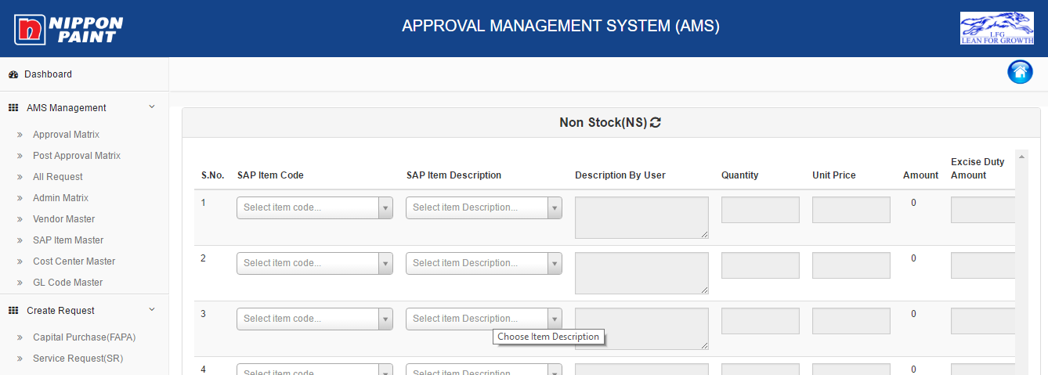





**3.3.1. SAP ITEM CODE*-** Mandatory drop down Option. (History Button will appear if the

item exists or item has history)

**3.3.2. SAP ITEM DESCRIPTION *-** Mandatory drop down searchable option (History

Button will appear if the item exists or item has history)

In Case user selects item code then description come automatically or vice versa.

**3.3.3. Description by user*-** Mandatory Text Box

**3.3.4. Quantity\*** – Mandatory Numeric Text Box (Blank)

**3.3.5. Unit Price**- Optional Numeric Text Box (Blank)

**3.3.6. Amount** - Automatic Calculation ( Qty*Unit price)

**3.3.7. Excise Duty** - Optional Text Box (Blank)

**3.3.8.** Once the user clicks on **Add Tax** **Button** - A pop up window will open



This is an optional field, but becomes mandatory if the user enters the unit price.

Fields like:

* **Tax Type**
* **Tax Percentage**
* **Tax Amount**

**3.3.9. Total Amount** - This will show the total amount (Pre-formulated i.e. Amount + Excise duty + Tax amount)

**3.3.10. Internal Order No.\*** : Blank Text Box. Internal order no will validate from the database and total request amount of FAPA will be equal or less than the internal order amount. If exceeds then message will be shown **“Requested amount is exceeding from the balanced amount of internal order.”**

**3.3.11. GL Code -** General Ledger Code

**3.3.12. Profit Center -** Drop Down Menu

**3.3.13.** Delete Button

**3.3.14. Add New Row** - This will add new rows with the above input fields.

**3.3.15. Vendor Details**

**a. Vendor Code\*** : Drop down Option – Mandatory field in case of amount given

**b. Vendor Name\*** : Drop down option- Mandatory field in case of amount given

If does not comes in searchable option then the user can select creation of vendor code

Note: if user selects Vendor code then name automatically appears and vice versa.

**3.3.16. Quotaion:** Quotation with browse options. One browsing attachment is mandatory if

vendor details have been filled up by the user otherwise none is compulsory.

After filling all the details, Four option are there:

* **Save** -This allows you to create the AMS form as draft and return to complete the requests that are pending due to item code creation or vendor code creation.
* **Submit** - This allows you to route the completed form to the next level.
* **Reset** - This allows you to reset the form before saving and return to complete the fresh request form.
* **Cancel** - This allows you to delete the form and return to fill the form again.

After Submission:

Case 1: Without Amount & Vendor details

* If user submits the form without giving the amount & vendor details then this request will go to Purchase dept.
* After purchase dept. submission, it will go to Divisional Head (D.H.)
* After approval of D.H., it will go Finance dept.
* After checking and approval of Finance dept., It will go to the president/D.H. for approval as per limits.

Process Flow:

User🡪Purchase dept🡪 Divisional Head 🡪 Finance 🡪President/D.H.🡪Purchase dept.

Case 2: With Amount & Vendor details

* If user submits the form with giving the amount & vendor details then this request will go to Divisional Head.
* After approval of D.H., it will go Purchase dept.
* After purchase dept. submission, it will go to Finance dept.
* After checking and approval of Finance dept., it will go to the president/D.H. for approval as per limits.

Process Flow:

**1. In case of no change in request**.

User🡪 Divisional Head 🡪Purchase dept.🡪 Finance 🡪President/D.H.🡪Purchase dept.

**2. In case of any change in request**.

User🡪 Divisional Head 🡪Purchase dept.🡪 Divisional Head🡪 Finance 🡪President/D.H.🡪Purchase dept.